**Institute of Engineering & Management**

**Department of Computer Science & Engineering**

**Software Tools Laboratory for 2nd year 4th semester 2018**

**Code: CS 492**

**Date:** 7/2/18

**WEEK-3**

**Assignment-1**

**Problem Statement:** Write a program to demonstrate the concept of the image box and the picture box. Display an image with image box and picture box both. Determine the difference between these two.

**Screen-Shot:**

**Form-1:**

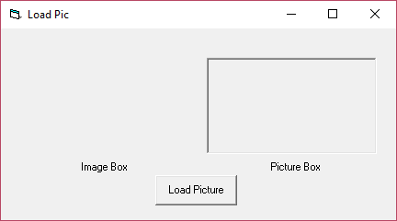

Before clicking Button

After clicking Button

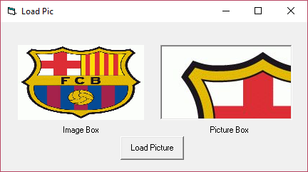

**Form Code:**

**For Form-1:**

Private Sub Command1_Click()  
Image1.Picture = LoadPicture("C:\Users\Ranajit\Pictures\barca.jpg")  
Picture1.Picture = LoadPicture("C:\Users\Ranajit\Pictures\barca.jpg")  
End Sub

**Assignment-2**

**Problem Statement:** Create three option buttons with the name India, Australia and England respectively. Show the images of cricket team jersey when the corresponding option button is selected.

**Screen-Shot:**

**Form-1:**

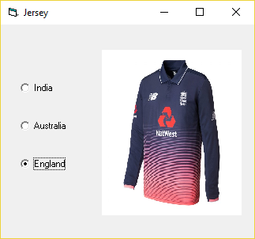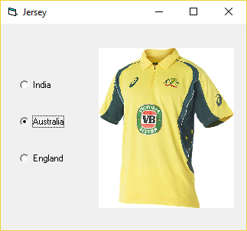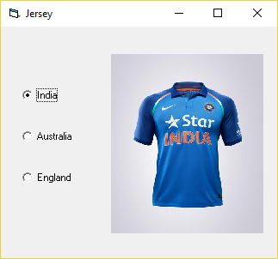

**Form Code:**

**For Form-1:**

Private Sub Option1_Click()  
Image1.Picture = LoadPicture("C:\Users\Ranajit\Pictures\india.jpg")  
End Sub  
Private Sub Option2_Click()  
Image1.Picture = LoadPicture("C:\Users\Ranajit\Pictures\australia.jpg")  
End Sub  
Private Sub Option3_Click()  
Image1.Picture = LoadPicture("C:\Users\Ranajit\Pictures\england.jpg")  
End Sub

**Assignment-3**

**Problem Statement:** Create a text box and a command button. You will type the name of an image in the text box. Then click on the button. The image typed in the text box will be displayed in an image box. Write a programme in VB to do this task.

**Screen-Shot:**

**Form-1:**

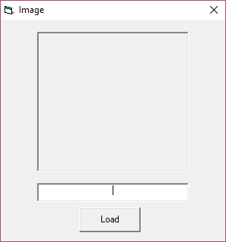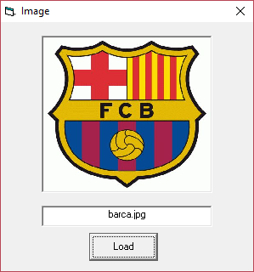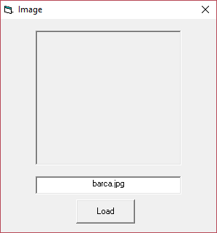

**Form Code:**

**for form-1:**

Private Sub Command1_Click()  
adr = "C:\Users\Ranajit\Pictures\"  
Image1.Picture = LoadPicture(adr + Text1.Text)  
End Sub

**Assignment-4**

**Problem Statement:** Draw a rectangle shape with shape tool. Create 6 option buttons as follows: -

* RECTANGLE
* SQUARE
* OVAL
* CIRCLE
* ROUNDED SQURE
* ROUNDED RECTANGLE

Write a program to change shape after clicking each option button. For every shapes, fill color, Border color, fill style must be changed

**Screen-Shot:**

**Form-1:**

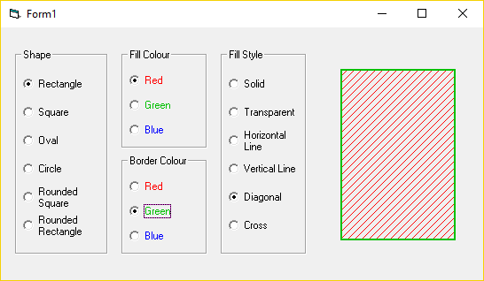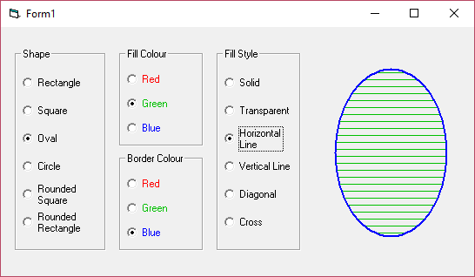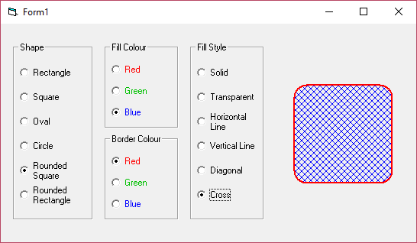

**Form Code:**

**For Form-1:**

Private Sub Option1_Click()  
Shape1.Shape = 0  
End Sub  
  
Private Sub Option2_Click()  
Shape1.Shape = 1  
End Sub  
  
Private Sub Option3_Click()  
Shape1.Shape = 2  
End Sub  
  
Private Sub Option4_Click()  
Shape1.Shape = 3  
End Sub  
  
Private Sub Option5_Click()  
Shape1.Shape = 5  
End Sub  
  
Private Sub Option6_Click()  
Shape1.Shape = 4  
End Sub  
  
Private Sub Option7_Click()  
Shape1.FillColor = &HFF&  
End Sub  
  
Private Sub Option8_Click()  
Shape1.FillColor = &HC000&  
End Sub  
  
  
Private Sub Option9_Click()  
Shape1.FillColor = &HFF0000  
End Sub  
  
Private Sub Option10_Click()  
Shape1.BorderColor = &HFF&  
End Sub  
  
Private Sub Option11_Click()  
Shape1.BorderColor = &HC000&  
End Sub  
  
Private Sub Option12_Click()  
Shape1.BorderColor = &HFF0000  
End Sub  
  
Private Sub Option13_Click()  
Shape1.FillStyle = 0  
End Sub  
  
Private Sub Option14_Click()  
Shape1.FillStyle = 1  
End Sub  
  
Private Sub Option15_Click()  
Shape1.FillStyle = 2  
End Sub  
  
Private Sub Option16_Click()  
Shape1.FillStyle = 3  
End Sub  
  
Private Sub Option17_Click()  
Shape1.FillStyle = 5  
End Sub  
  
Private Sub Option18_Click()  
Shape1.FillStyle = 7  
End Sub